Retail Sales Analytics Dashboard — Week 2
Sales & KPI Analysis

1. Objective
Analyze overall business performance, sales trends, regional performance and category performance using the cleaned Superstore Sales dataset.

2. Core KPI Calculations
- Total Sales: $2,297,200.86 — Total revenue generated
- Total Profit: $286,397.02 — Total profit generated
- Total Orders: 5,009 — Number of unique orders
- Total Customers: 793 — Number of unique customers
- Total Quantity Sold: 37,873 — Total units sold
- Profit Margin: 12.47% — Total Profit ÷ Total Sales
- Average Order Value: $458.61 — Total Sales ÷ Unique Orders

3. Sales Over Time
Annual sales increased from $484,247.50 in 2014 to $733,215.26 in 2017, an overall increase of 51.4%.
Highest cumulative calendar month: November ($352,461.07).
Lowest cumulative calendar month: February ($59,751.25).
The monthly trend should be reviewed for recurring peaks and weaker periods when planning inventory and promotions.

4. Regional Analysis
Highest sales region: West ($725,457.82).
Highest profit region: West ($108,418.45).
The same region leads both sales and profit.

5. Category Analysis
Highest sales category: Technology ($836,154.03).
Highest profit category: Technology ($145,454.95).
Lowest category profit: Furniture ($18,451.27).

6. Visualizations
01 Core KPIs
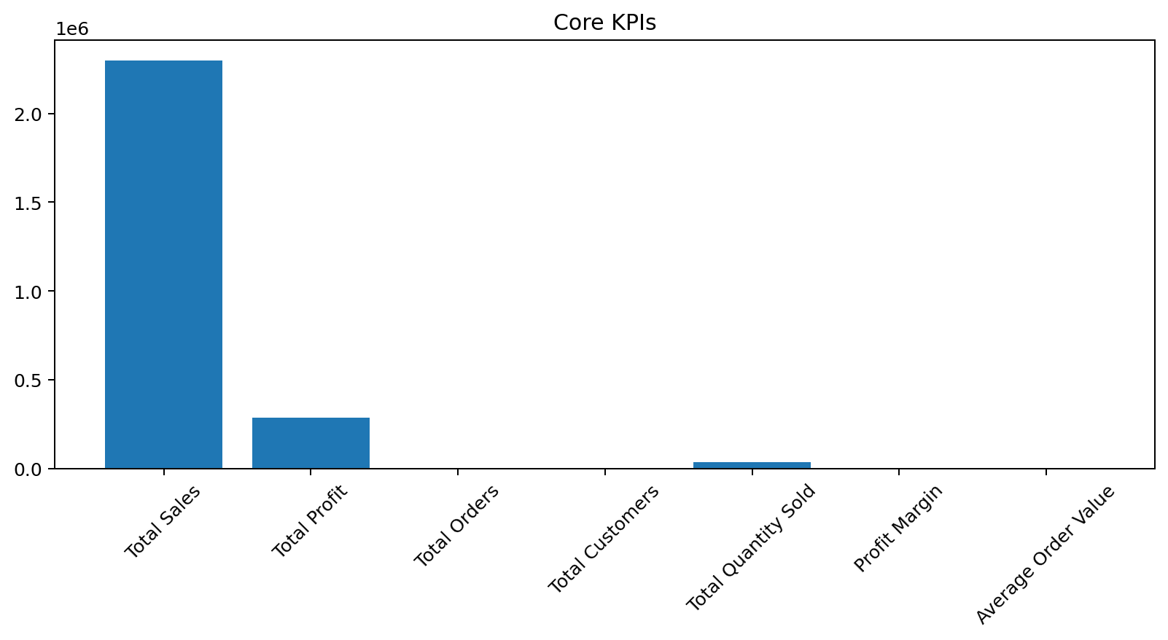
02 Sales by Year
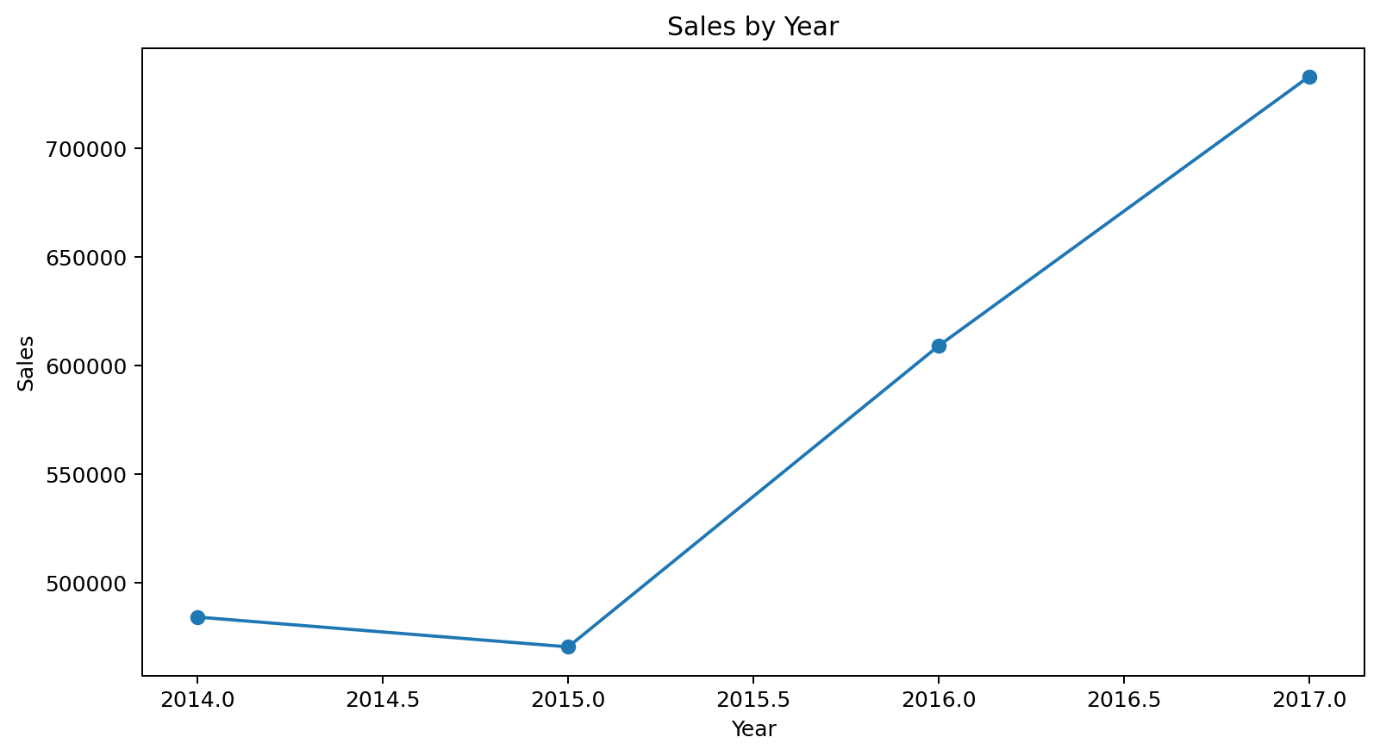
03 Monthly Sales Trend
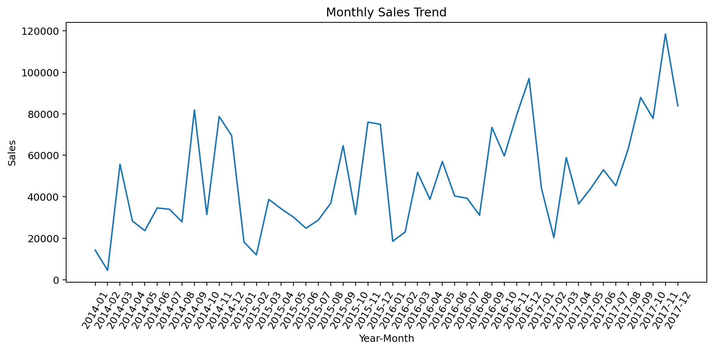
04 Monthly Profit Trend
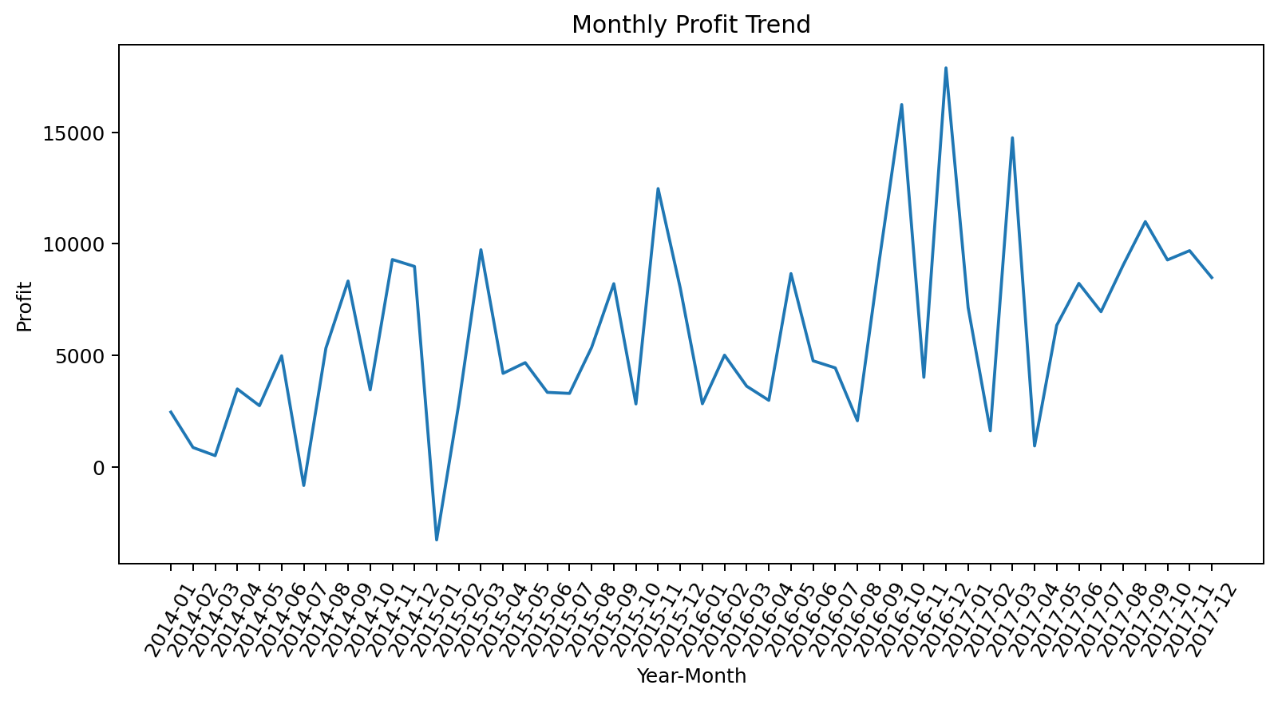
05 Sales by Region
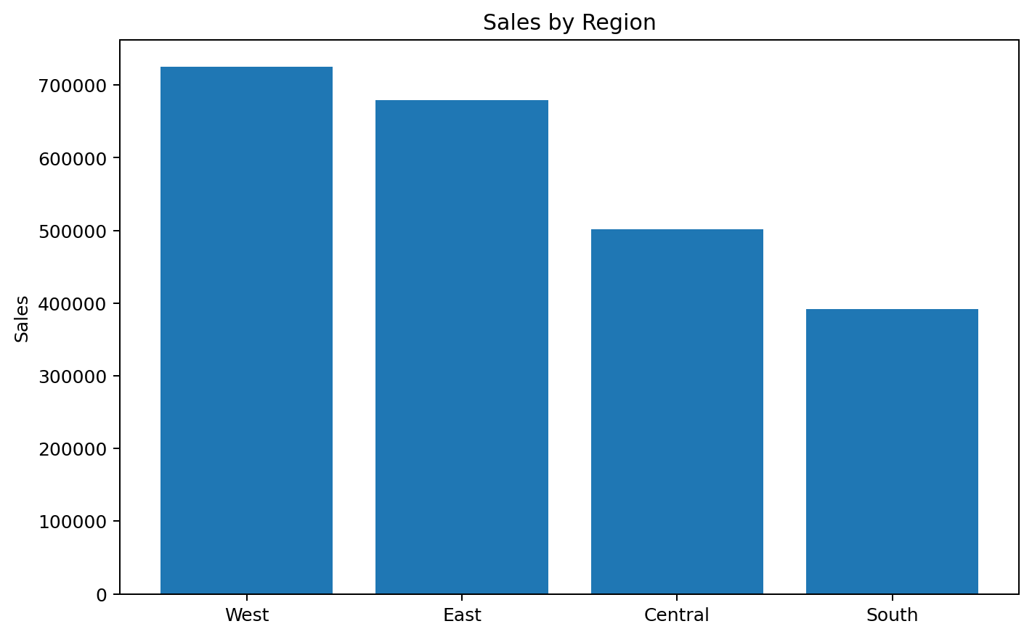
06 Region Sales vs Profit
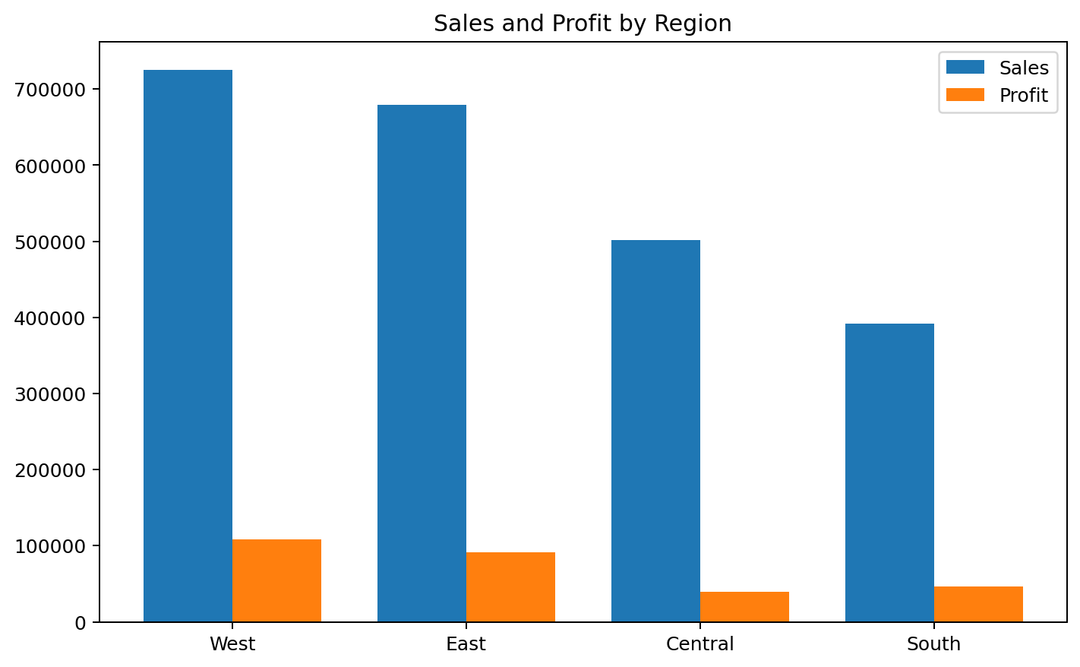
07 Sales by Category
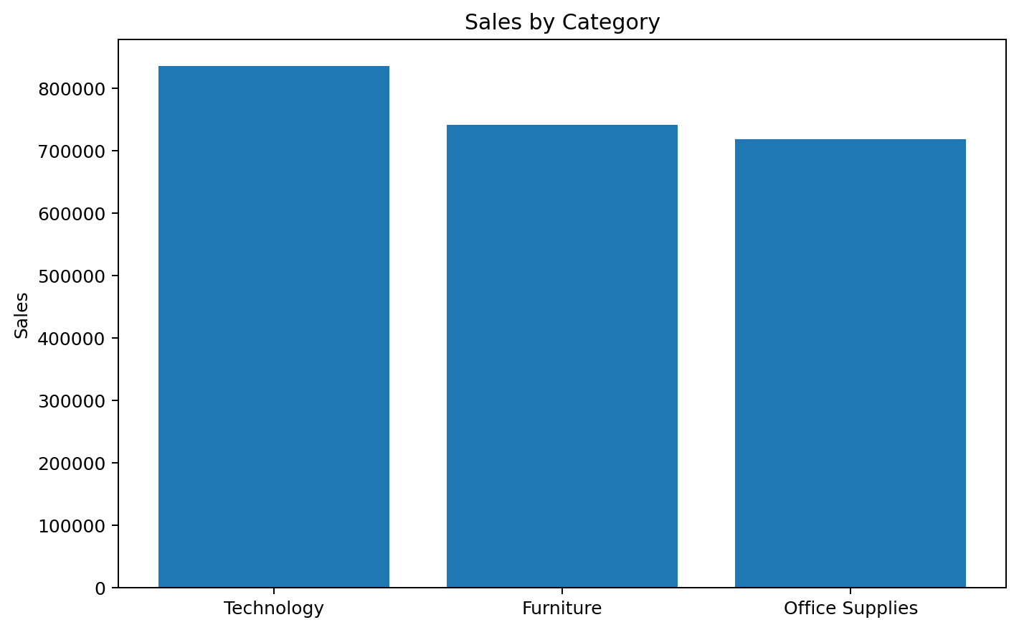
08 Category Sales vs Profit
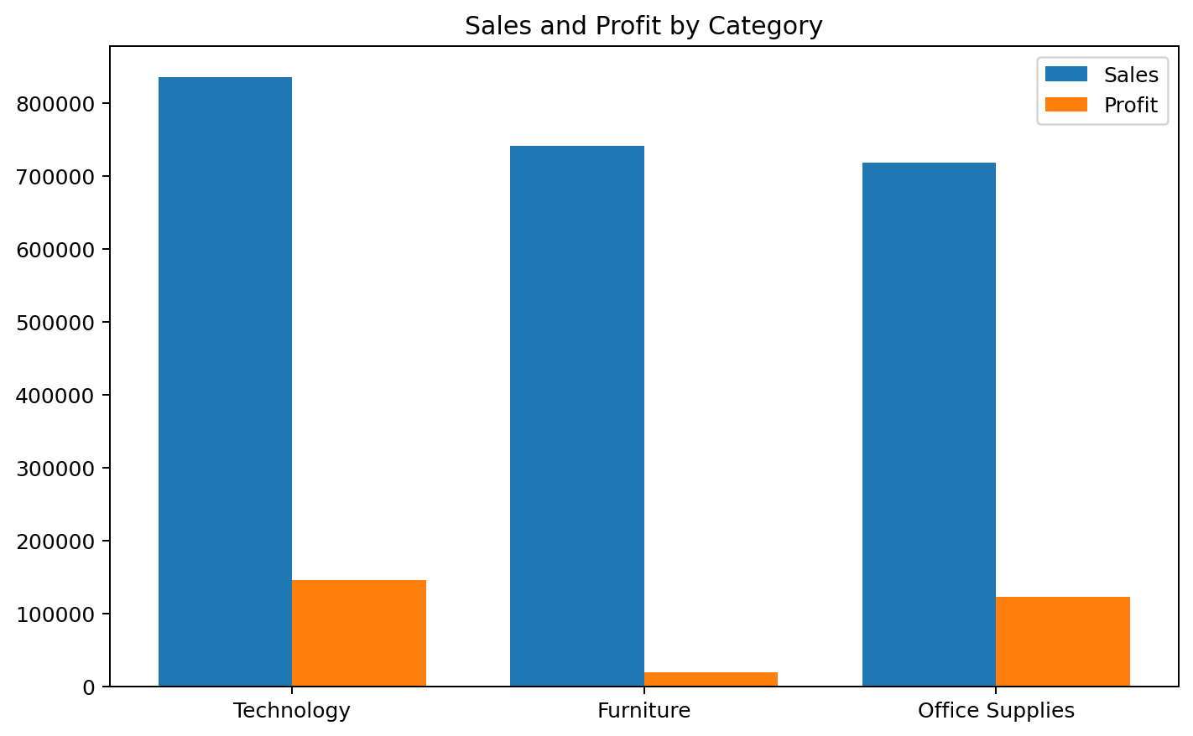

7. Business Insights
- The business generated $2,297,200.86 in total sales and $286,397.02 in total profit across 5,009 unique orders.
- Total sales increased by 51.4% from 2014 to 2017, indicating an overall upward sales trend.
- November generated the highest cumulative sales across the dataset at $352,461.07, while February generated the lowest at $59,751.25.
- West generated the most sales at $725,457.82; the region generating the most profit was West at $108,418.45.
- The highest-sales category was Technology with $836,154.03, while Technology generated the most profit at $145,454.95.
- Furniture had the lowest category profit at $18,451.27, so its product mix, discounts and costs warrant management attention.

8. Recommendations
- Continue monitoring the strongest sales region (West) and identify the products and customer groups driving its performance.
- Investigate the difference between the highest-sales region (West) and highest-profit region (West) to understand margin differences.
- Review the profitability of Furniture by sub-category and product, especially where high discounts may reduce margins.
- Use monthly sales and profit trends to plan inventory, promotions and staffing around stronger and weaker periods.
- Track Average Order Value and Profit Margin together so that revenue growth is evaluated alongside profitability.

9. Week 2 Deliverables Checklist
✓ KPI calculations
✓ Sales trend analysis
✓ Regional analysis
✓ Category analysis
✓ At least 6 visualizations
✓ Minimum 5 business insights

